Firing cheat sheet
Bisque
Loading
- Arrange pots according to size
- Check for dust in kiln
- As you load shelves, dust top and scrape bottoms
- Check that cable is elevated off the floor
- Clean top and bottom of posts before inserting into kiln (kiln wash on post can make them stick to shelves)
- Witness cone pack inserted in kiln near peep holes
- Remember: mugs should be loaded with handles facing inward
Programming the computer controlled kilns
- Turn power on
- Should see IDLE if not, press ENTER
- Press slow bisque
- ENTER
- Type cone #. Example: Bisque: 06 (optional cone 05 to burn off additional impurities in clay)
- ENTER
- IDLE TC 2 will display briefly, then current temperature
- Setting preheat to extend the firing schedule (Remember must be present for first and last 2 hours of firing)
  - Press other x2 to set preheat (Slow bisque cone 06 ~ 12 hrs)
  - Preheat time = # of hours until you want firing to end – 12 (firing time) - 1 to bring temperature to preheat
  - Example below: kiln start at 8 pm which is 15 hours away from 11 am: 15-12-1 = 2 hours preheat required
  - For 2 hours, type 200 then ENTER
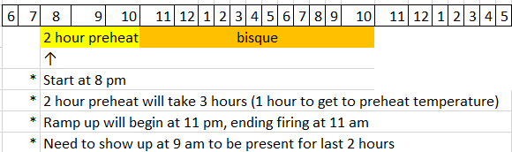
- Review program
- Press START
- Last minute check:
  - Peep holes closed
  - Latch is on
  - Fans are on
  - Make sure lid is aligned with bottom (Kiln 2 & 3 in particular)
Firing is completed:
- Register ending temperature & length of time
- Turn off kiln
- Close fans
- Crack the lid and open the peeps when the temperature is about 100° C or 200° F
- Kiln lid may be open when the temperature is down to 52° C (125° F) or below.
Unloading
- Inspect and record shelves in book, scrape and kiln wash those requiring attention
- Vacuum kiln thoroughly
GLAZE
Loading
- Arrange pots according to size
- Check for dust in kiln
- As you load shelves, dust top & scrape bottoms
- Cables elevated off the floor
- Clean top and bottom of posts before inserting into kiln (kiln wash on post can make them stick to shelves)
- Ensure bottoms of pots are cleaned, use cookies when possible.
- Witness cone pack inserted in kiln near peep holes
Programming the computer controlled kilns
- Turn power on
- You should see IDLE, if not press ENTER
- Press slow glaze
- ENTER
- Enter cone
  - Glaze 6 (optional cone 5 with 15 minute hold)
to correct press 000 then enter
- ENTER
- Soak or hold (10-30 minutes) or leave at 0
- ENTER
- IDLE TC 2 will display briefly, then current temperature
- Setting preheat to extend the firing schedule (Remember must be present for first and last 2 hours of firing)
  - Press other x2 to set preheat (Slow glaze cone 6 ~ 9 hrs)
  - Preheat time = # of hours until you want firing to end – 9 (firing time) - 1 to bring temperature to preheat
  - Example below: kiln start at 8 pm which is 13 hours away from 9 am: 13-9-1 = 3 hours preheat required
  - For 3 hours, type 300, then ENTER

  - 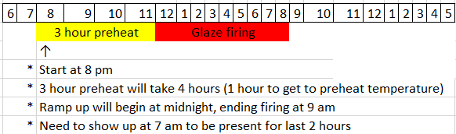
- Review program
- Press START
- Last minute check:
  - Peep holes closed
  - Latch is on
  - Fans are on
  - Make sure lid is aligned with bottom (Kiln 2 & 3 in particular)
Firing is completed:
- Register ending temperature & length of time
- Turn off kiln
- Close fans
- Crack the lid and open the peeps when the temperature is about 100° C or 200° F
- Kiln lid may be open when the temperature is down to 52° C (125° F) or below.
Unloading
- Inspect and record shelves in book, scrape and kiln wash those requiring attention
- Vacuum kiln thoroughly

